Hazards faced by Barn Owls

About four years ago we were asked by John Lightfoot of the Shropshire Barn Owl Group if he could put an owl box in our hay barn and we agreed. Over the years the box remained unused by any owls until January 2013 when a pair of Barn Owls decided to set up home in it and we could see the pair flying around the barn. Over the last few months we watched the owls busy hunting over the land and flying around the farmyard, all was going well for the pair and we were looking forward to the owls nesting in their owl box and raising their young,
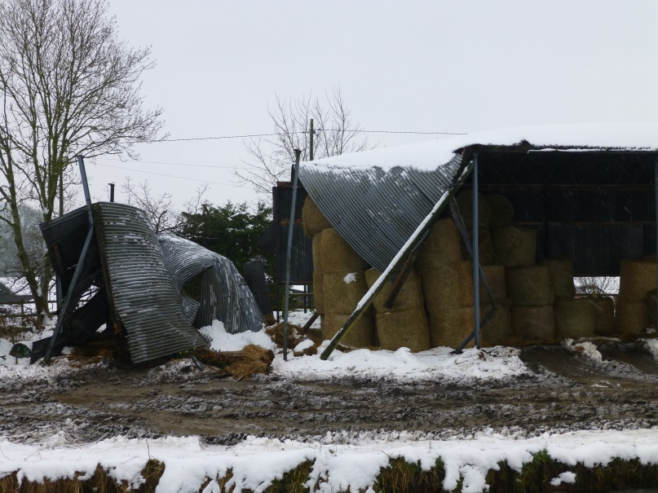
However disaster struck on the 23rd March 2013 as twelve inches of snow arrived causing the barn to collapse under the extra weight. The barn was crumpled by the snow and the owl box was thrown to the ground buried under the remains of the barn and one of the owls was found dead on the floor killed by the snow storm.

After the barn had collapsed we saw the surviving Barn Owl flying around the farm calling for its mate and patrolling the areas they used to hunt trying in vain to find the mate that was now dead. On the 26th March at 9:30 am we saw the owl flying nearby as we were taking feed to our sheep in the fields due to the snow been too deep for them to eat the grass, However this was to be the final flight for the owl as a buzzard suddenly swooped down from above and claimed the life of the lonely bird. We have watched the pair of buzzards that have lived on our farm over the years, but this was the first time we have seen them attack an owl and so we no longer have any Barn Owls living on our farm.

Glyn and Delia

